# **ACRTA**

# NEWS **AND MUSE**

**Volume 10 Issue 1**

**February 2019 – March 2019**

 **RAFFLE** – **WINTER SURPRISE**

**Proceeds benefit “Teachers Grant Program”**

**Tickets: $2.00 each or 3 for $5.00**

**MEMBERSHIP 2019**

**ACRTA $12**

**ORTA $30**

**TOTAL $42**

**CONTACT: BARB HOCHSTETLER**

**3135 TAWA DRIVE**

**LIMA, OHIO 45806**

**bhochstetler001@woh.rr.com**

**United we stand strong!**

**The next lunch meeting will be held on**

**FEBRUARY 7TH 11:30 am**

**Westside UMC**

***MENU1.* Juice/Crackers, Chicken Casserole, Broccoli, Rolls, Beverage and Peppermint Ice Cream Dessert**

***MENU2.* Juice/Crackers, Baked Potato, Glazed Carrots, Broccoli, Rolls, Beverage and Peppermint Ice Cream Dessert**

**Send RSVP and $15 check to: Norma Penn**

**809 Brendonwood Drive**

**Lima, Ohio 45801**

**419-303-8431**

The Program for ACRTA June 7th will be the **VETERANS FOOD PANTRY**

We will take donations of can goods, non-perishable items and/or personal care items. Bring them to the meeting and we will deliver them for you.

  

We will take donations of can goods, non-perishable items and/or personal care items. Bring them to the meeting and we will deliver them for you.

 News from Our President

Message from the President of ACRTA – I would like to first thank Jim Schwabero for serving as the president for the last four years and to Norma Penn for carrying out the duties as our secretary. With their commitment we have continued to move forward as an organization to be involved in our community.

I look forward to working with the membership to expand our outreach in the schools and community. Please feel free to contact me with questions (I will try to find an answer), comments, concerns, or even what you like that our association is doing. I brought several ideas to the Board of Directors and with their approval we will share them at our next meeting to get feedback from the members that are present.

At our February meeting we will have a memorial service to remember and pay our respects to our fellow educators that have passed during 2018. We hope that you can join us for our luncheon, short business meeting and time of remembrance. You may want to share a memory or a few words to honor one of these persons.

Our organization wants to be active in supporting the active teachers in Allen County. We will be reviewing our $200 Teacher Grant Applications and awarding them in March. All proceeds that are collected throughout the year through 1) $2.00 of each membership, 2) the raffle at our bi-monthly meetings, 3) extra contributions that have been made at the time a membership is sent in (THANK YOU TO THOSE THAT HAVE BEEN SO GENEROUS IN ADDING TO YOUR MEMBERSHIP AMOUNT TO SUPPORT THE GRANTS), 4) loose change at the luncheon tables, and 5) a few local businesses that have made contributions. This amount supports the creative and unique ideas for the educators working with the students in Allen County. Mary Wilkins and Mila Schwabero lead this project. Last year we were able to award 10 grants in the amount of $1,786.67. Since the beginning of the project in 2013 we have been able to award 53 grants in the amount of $9,737.17. If you or an organization would like to donate to this project at any time, you can send your contribution to Mary Wilkins at 155 N. Seriff Dr., Lima, OH 45807 Thank You!!

Our members have reported 7,710 hours of volunteer time in our community for last year. If you have volunteer hours to report please send that information to Jim Schwabero at [jschwabero@woh.rr.com](mailto:jschwabero@woh.rr.com) or call him at 419-236-2074.

We certainly do make a difference!

2019 – May it bring good health, peace, and happiness!

Barbara Hochstetler

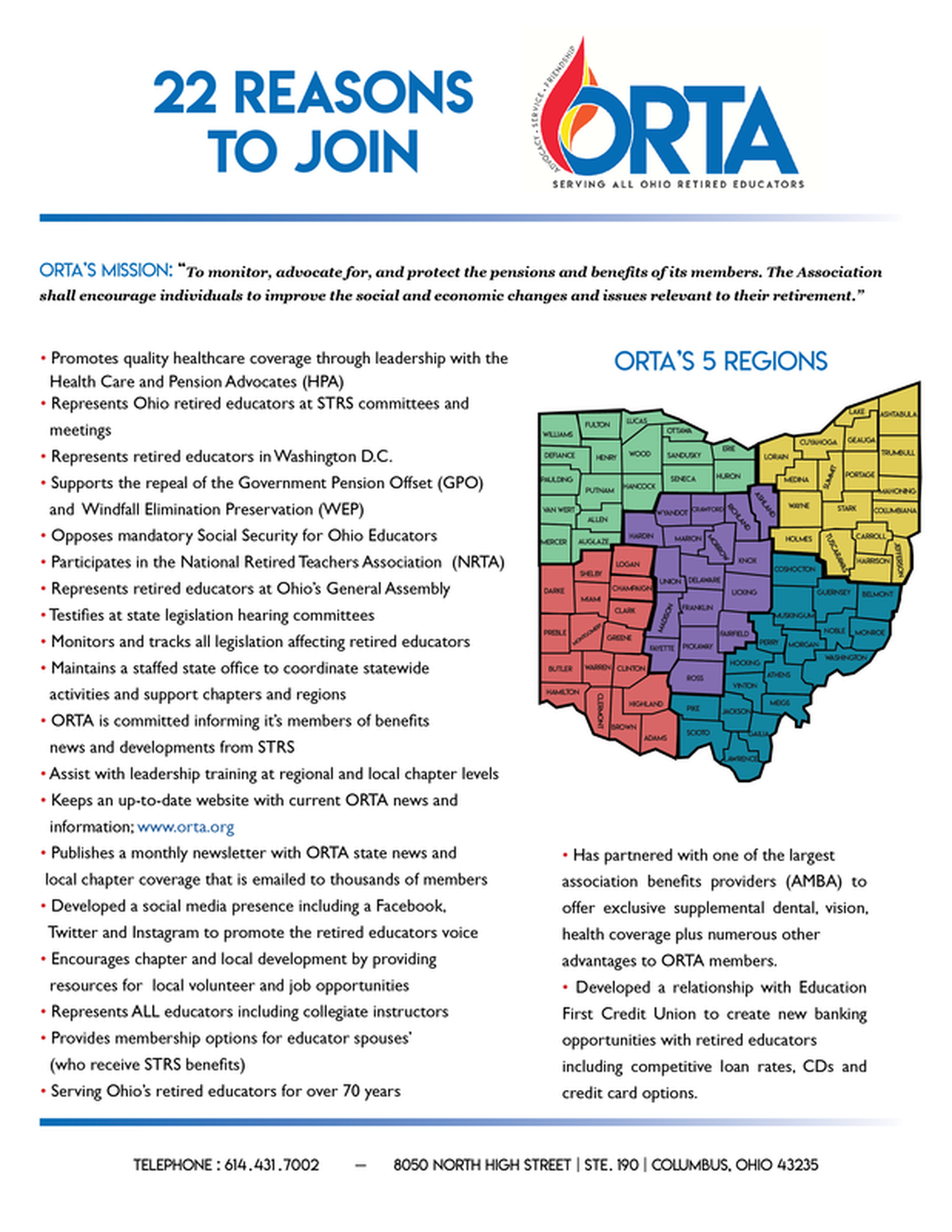



 

**BIRTHDAYS**

|  |  |  |  |  |  |  |  |  |  |  |  |
| --- | --- | --- | --- | --- | --- | --- | --- | --- | --- | --- | --- |
| Corbett, Marybeth | Feb. 2 | Earl, Kathy | March 9 |  |  |  |  |  |  |  |  |
| Sanders, Michelle | Feb.5 | Foltz, Howard | March 9 |  |  |  |  |  |  |  |  |
| Schwabero, Jim | Feb. 5 | Langhals, Paula | March11 |  |  |  |  |  |  |  |  |
| Goetz, Darlene | Feb. 10 | Holman, Linda | March12 |  |  |  |  |  |  |  |  |
| Wisenhahn, Maureen | Feb. 14 | Fell, Phyllis | March14 |  |  |  |  |  |  |  |  |
| Hadding, Kathy | Feb. 15 | Lauless, Pam | March17 |  |  |  |  |  |  |  |  |
| Koch, Phyllis | Feb. 16 | Clover, Bob | March19 |  |  |  |  |  |  |  |  |
| Ballentine, Maggie | Feb. 17 | Clark, Sylvia | March20 |  |  |  |  |  |  |  |  |
| Recker, Frederick | Feb. 21 | Darbyshire, Carol | March26 |  |  |  |  |  |  |  |  |
| Stepleton, Mary | Feb. 21 | Cooper, Irene | March27 |  |  |  |  |  |  |  |  |
| Blanchong, Margaret | Feb. 24 | Washam, Deb | March28 |  |  |  |  |  |  |  |  |
| Quay, Cheryl | Feb. 24 |  |  |  |  |  |  |  |  |  |  |
| Bowsher,Samuel | Feb.24 |  |  |  |  |  |  |  |  |  |  |
| Hensley, Richard | Feb.28 |  |  |  |  |  |  |  |  |  |  |



LEGISLATIVE NEWS

|  |  |  |
| --- | --- | --- |
|  |  |  |

The Supreme Court is scheduled to return to a deeply divisive issue on Friday, 1-11-2019, when the justices meet behind closed doors to discuss an issue left unresolved last term: when do states go too far in drawing district lines for partisan gain?

The court has never established a standard to resolve extreme partisan gerrymanders, and if it chooses to do so, it could revolutionize the way congressional and state legislative maps are drawn.

The issue often divides conservatives, who have suggested that courts should steer clear of such political disputes, and liberals, like Justice Elena Kagan, who contend that courts should be able to articulate a standard to combat a practice she believes "enables politicians to entrench themselves in power against the people's will."

**Bruce Hodges**



**Bruce Hodges**

**1419 Wendell Ave.**

**Lima, Ohio 45805**

