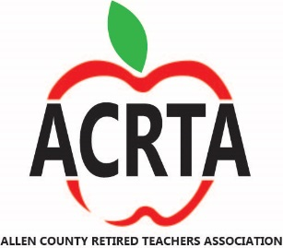

**NEWS AND MUSE - VOLUME 10 ISSUE 4 - JUNE – JULY 2019**

**LUNCHEON JUNE 6TH IMMANUEL UNITED METHODIST CHURCH**

** RAFFEL FOR TEACHER GRANTS**

**1 TICKET $2 OR 3 TICKETS $5**





We will take donations of can goods, non-perishable items and/or personal care items. Bring them to the meeting and we will deliver them for you.



**MENU FOR JUNE**

Appetizer

Taco Bar with many topping choices (vegetarian meal will have kidney beans/taco sauce instead of beef)

Banana Pudding

Beverage

RSVP by May 31 to Norma Penn at 419-303-8431 or [nleigh27catz@aol.com](mailto:nleigh27catz@aol.com) or mailing address is 809 Brendenwood Drive Lima, Oh 45801

If you just want to join us and not eat you are welcome to come and have conversation with fellow educators at the table. We enjoy your company.

**JUNE GUEST SPEAKER**

At our June meeting, Cheryl Parson from the Better Business Bureau will be our guest speaker talking about scams. Also, the superintendent from Apollo, Keith Horner, will give a short update of what is happening at Apollo Career Center.

**VOLUNTEER HOURS**

As an organization we send the number of volunteer hours that our members have given in our community organizations and other areas of interest to ORTA at the end of each year. At our meeting many members fill out the number of hours they have given on the paper provided at each table. Some members can’t attend our meetings because they are volunteering on that day. Many of our members volunteer and we would like to count your hours in our total. Please send an e-mail or call with your hours so that we can show what a difference we make as retired educators. Send the information to Jim Schwabero at 419-236-2074 or [jschwabero@woh.rr.com](mailto:jschwabero@woh.rr.com)

**Message from the President:**

Many of us are concerned about out COLA. Here is some information to help you understand more about what is happening.

This was from the ORTA newsletter in April.

The following statement was made by ORTA Executive Director, Dr. Robin Rayfield at the monthly STRS Board Meeting held on April 18, 2019.

“Greetings STRS Board of Trustees and Staff. My Name is Robin Rayfield and I represent the Ohio Retired Teachers Association. I am a STRS beneficiary, having retired in 2011 after 30+ years of service. I want to acknowledge the Board’s recent discussion regarding the Funding Policy at STRS and this policy’s impact on current retirees; specifically, COLA. ORTA members are encouraged by the board’s decision to discuss this policy and encourage more detailed discussions on this policy and its implications. The current Funding Policy and the notion that benefit enhancements/COLAs are not feasible until the system reaches a level of 100% funding are of great concern. Let me be clear, ORTA supports the Board’s desire to achieve a funding status of 100%. ORTA disagrees, however, that this desire should be a policy. It is unacceptable for ORTA members to be denied increases in benefits until 2034. Under the current Funding Policy, a great % of current retirees will not be alive in 2034 when STRS will achieve a level of 100% funding. Instead, ORTA believes that progress should be made toward the goal of reaching 100% funding, but that this goal or guiding principle should not prevent retirees from receiving what was guaranteed at the time of their retirement. Certainly, retirees have been patient and have demonstrated this patience over the last few years of losing their benefits. However, now is the time for the Board of Trustees to abandon the 100% status as a policy and, instead, view 100% funding status as a goal or guiding policy. Progress towards this goal is reasonable, adherence to this as a policy resulting in a failure to meet obligations is not acceptable. ORTA suggests that the Board review historical funding levels STRS has experienced as a guide to determine policy development, not an unrealistic 100% funding level. I’m sure that you will determine that STRS has rarely achieved a 100% funding level and has historically been at a level nearer to where we are at currently than 100%. In closing, I suggest that STRS use the following analogy as this discussion unfolds: Comparing STRS’s funding levels to our current levels of CO2 and their impact on climate change makes sense to me. We should reduce carbon emissions as it is good for our planet, just as making progress on reaching 100% funding is good for our pension system. However, we need fossil fuels to heat our homes, provide power to our factories, and to power our vehicles. The US has reduced emissions and have policies in place to reduce emissions, however, we all drove here to this meeting today. STRS should develop policies that allow retirees to continue to receive what they were promised, while making progress towards a 100% funding status.”

Listed below are opportunities that fellow Ohio retirees are reading to keep abreast of information. I wanted to share this information with you as well. ORTA also provides information about current issues.

1. Google "restoreourcola.com" and sign an online petition. Over 17,500 already have.

2. Google "strsohcola.com" for up-to-date information about our COLA and other topics of interest highlighting member concerns with STRS.

3. Google "kathiebracy.blogspot.com" which is a forum for Ohio educators sharing thoughts regarding their health care and pension systems. The archives go back to 2005 and this blog is a wealth of evolving STRS decisions affecting us.

4. If you are on Facebook and want to follow minute by minute posts by fellow retirees and active teachers, then use the Facebook search and type "STRS Member Only Forum Public Group" and complete the "join" section to follow this group.

5. ORTA website - https://www.orta.org/

This is a hot topic and it affects all of us. Keep informed.

Hoping for sunshine and a little warmer weather – Barb

Contact me at 419-303-5667 or [bhochstetler001@woh.rr.com](mailto:bhochstetler001@woh.rr.com)

**PARTNERSHIP WITH ALLEN COUNTY MUSEUM**

An opportunity to help with our partnership with the Allen County Museum.  
  
The Allen County Museum will be presenting a display of quilts that were donated to the museum. These quilts have been in storage for many years. The show will start in June 15 and will end September 7.  
  
They are looking for people to volunteer to help with security during the show. This would consist of just keeping an eye on people to make sure they don’t touch or harm the quilts. Information will be available for the helpers about the quilts. The show will be during regular museum hours: Tuesday - Friday: 1:00 - 4:00 p.m. and Saturday & Sunday: 1:00 - 4:00 p.m.  
  
If volunteers can only do a one, two- or three-hour section that is fine. Contact Barb Hochstetler (419-303-5667) if you are able to help. She will pass on the information and days/times you might be available to help.

**BIRTHDAYS FOR JUNE & JULY**



**JUNE JULY**

|  |  |  |  |
| --- | --- | --- | --- |
| **Lila B. McGovern** | **June 3** | **Sarah Arnett** | **July 1** |
| **Greg Miller** | **June 3** | **Edward Hoffmeyer** | **July 3** |
| **Leah Richardson** | **June 9** | **Stephanie Miller** | **July 3** |
| **A.J. Keasler** | **June 10** | **Carolyn Huffman** | **July 4** |
| **Roger Rhodes** | **June 13** | **William Herr** | **July 5** |
| **Ann Bercaw** | **June 14** | **Deb Pauff** | **July 6** |
| **Wendell Badertscher** | **June 16** | **Sharon Cheney** | **July 7** |
| **Kaye Keller** | **June 16** | **Ethel Nelson** | **July 9** |
| **David Hochstetler** | **June 17** | **Donald Miller** | **July 10** |
| **Sue Zickafoose** | **June 17** | **Karen Foltz** | **July 12** |
| **Paula Millhoff** | **June 19** | **Joanne Guy** | **July 12** |
| **Jerome Matchem** | **June 22** | **Beverly McCoy** | **July 12** |
| **Ted Savidge** | **June 22** | **Jeanne Smith** | **July 12** |
| **Jamie Orr** | **June 23** | **Lorna Birt** | **July 13** |
| **Carol Hearne** | **June 24** | **Stan Carder** | **July 15** |
| **Art Holman** | **June 26** | **Patrice Keating** | **July 15** |
|  |  | **Sam Boyer** | **July 19** |
|  |  | **Corine Brown** | **July 20** |
|  |  | **Elizabeth Eley** | **July 22** |
|  |  | **Annette Gaeth** | **July 23** |
|  |  | **Joyce Acheson** | **July 27** |
|  |  | **Sally Farnholtz** | **July 27** |
|  |  | **John Mason** | **July 27** |
|  |  | **Dougie Franklin** | **July 29** |
|  |  | **Tom Gordon** | **July 29** |
|  |  | **Milena Howald** | **July 29** |
|  |  | **Kathy Dixon** | **July 31** |

**Election of Officers for 2020**

**Vice President and Treasurer**

**Current officers will Mentor you in this job until you are comfortable**

**You Can Do This – Nominate Yourself – You Can Make a Difference**

**You Can Do This – Nominate Yourself – You Can Make a Difference**

**LEGISLATIVE REPORT**

**ACRTA Legislative Chairperson, Bruce Hodges**

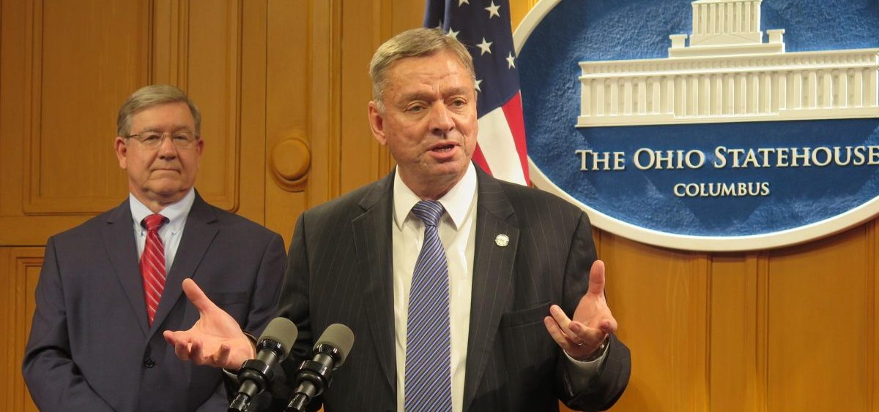

**Bipartisan plan seeks new school funding system for Ohio**

Reps. Bob Cupp, R-Lima, (Office Ph: 614-466-9624) and John Patterson, D-Jefferson (Office Ph: 614-466-1405) are proposing a new school funding plan. This bipartisan Fair School Funding Plan studied the impact of poverty on schools. Their study resulted in a new plan that calls for the following.

1. Establishing how much it costs to educate the average student in a typical school district.
2. Determining the best teacher-student ratio for each grade level
3. Funding high quality preschool for all economically disadvantaged 4-year-olds.
4. Providing a technology device for each student.
5. Determining the local share of funding based on the community’s property wealth and income.
6. Providing additional state funding of $422 per student living in poverty, up from the current $272.
7. Increasing funds for special education students.

The Ohio Education Association and the Buckeye Institute both commended the research and effort from Cupp and Patterson’s work group but said more work remains to settle on an effective funding formula. Please feel free to call and share your thoughts with these two pro-education legislators.

The future funding of public schools is important to current public-school teachers and all public-school students. Current public-school teachers are important to all retirees since they are currently paying into STRS to support our current retirement checks and their own future retirement plans. This effort is important to all public-school educators and the children of Ohio.

*You are invited to attend our June 6th 2019 meeting at the Immanual United Methodist Church, 699 Sunnydale St., Elida, Ohio, at 11:30 am. Bring your spouse and a fellow retired educator to enjoy the fellowship and learn more about the future of our retirement plan. Knowledge is power and together we can protect your retirement.*

*YOU ARE IMPORTANT TO ALL OF US!*

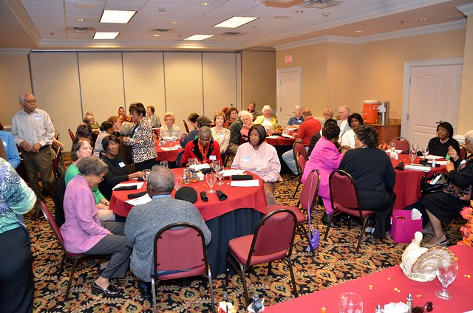

**Teachers are the past, present, and future of our nation and also our civilization.**

**BRUCE HODGES**

**1419 WENDELL AVE.**

**LIMA, OHIO 45805**

**MOTTO FOR TEACHERS**

**“I can explain it to you,**

**But I cannot understand it for you.”**