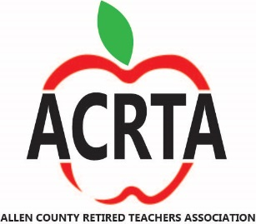
NEWS AND MUSE
VOLUME 12 ISSUE 5 OCTOBER-NOVEMBER 2022
~ ~ ~ ~ ~ ~ ~ ~ ~ ~ ~ ~ ~ ~ ~ ~ ~ ~ ~ ~ ~ ~ ~ ~ ~ ~ ~ ~ ~ ~ ~ ~ ~ ~
OCTOBER meeting
Thursday, October 6th at 11:30 A.M
Where: Immanuel United Methodist Church
699 Sunnydale Street, Elida
Lunch: Appetizer, Beef & Noodles, Mashed Potatoes, Cole Slaw, Roll, Apple Crisp, Beverage
Program: Dr. Randy Overbeck’s award-winning series, The Haunted Shores Mysteries, has inspired a new, entertaining program entitled “Things Still Go Bump in the Night”. This multi-media presentation explores interesting reports on real ghosts throughout the years, some common beliefs and misconceptions about “the spirit world” and even some controversial photos and a video of actual ghost hauntings you’ll have to see to believe. Hold onto your seats.
Raffle Item: Basket of Fall Themed Items

RSVP: NO LATER THAN October 3rd to Norma Penn at 419-303-8431 or nleigh27catz@aol.com
Cost for the lunch is $15 to be paid to Norma at the meeting.
Please do not send your RSVP in the mail as it may not get to her in time.

**If you just want to join us and not eat you are welcome to come and have conversation with fellow educators at the table. We enjoy your company.
If you need a ride to the meeting call or text Barb Hochstetler at 419-303-5667.
The election of a new president and secretary will take place and the revision of the bylaws will be presented. Our new book, Memories from the Schoolhouse! will be available in print to purchase.All proceeds will go the the Dr. John Rockhold Teacher Grant Fund.
WE HOPE TO SEE YOU THERE !!
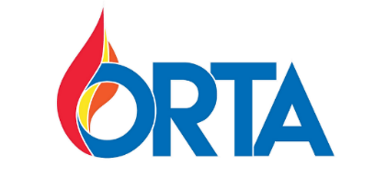
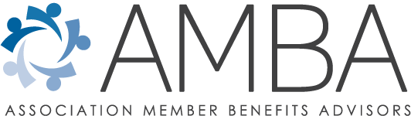

Why Consider AMBA Benefits?
Since 2005, the Ohio Retired Teachers Association (ORTA) has partnered with Association Member Benefits Advisors (AMBA) to provide a wide variety of insurance and consumer discount programs designed to help ORTA members enjoy greater financial security in retirement. The partnership has also resulted in AMBA associates bringing in over 4,500 new members, with 464 in 2021, and on pace to exceed that number in 2022.
AMBA specializes in serving the needs of active and retired public sector employees and is currently partnered with more than 80 associations across the country, including 33 statewide retired educator associations like ORTA. The company has nearly 40 years of experience analyzing the benefits that public sector employees receive in retirement and identifying gaps in coverage. With the collective buying power of millions of public sector employees/retirees, AMBA then negotiates with A-rated insurance carriers to provide plans that fill these gaps.
The company’s goal is to give ORTA members access to plans that either provide more benefits or charge lower fees than plans offered to individuals in the general marketplace. Membership in the ORTA state association is required for individuals to participate in the AMBA benefit programs.
Additionally, AMBA representatives are contractually obligated to educate ORTA members on the benefits available to them, and to place service before self when discussing and seeking to serve the members’ needs. AMBA representatives are held to account by the association for how they work with ORTA members. Insurance agents operating in the general marketplace have no such oversight.
Please call 614-205-0682 or email scott.judd@amba.info to schedule a meeting a AMBA representative, discuss your needs, and review all the benefits available to you as an ORTA member.
In future newsletters we will share information on some of the services available. You can find out more information about these benefits and discounts now at the following website -
https://www.myambabenefits.info/orta

Remember to follow and join these sites on Facebook to learn more about what is happening at STRS.
Ohio STRS Member Only Forum STRS Ohio Watchdogs Allen County Retired Teachers

STRS BOARD MEETING DATES that you may want to attend or listen to on the ORTA website.
- Oct. 20, 2022
- Nov. 17, 2022
Dan MacDonald's report on the STRS Board meeting of September 15. 2022
From Dan MacDonald
September 18, 2022
Dan MacDonald and Rob Walters attended the September 15, 2022 STRS Board meeting which featured three new Board members - Steven Foreman, Elizabeth Jones, and Julie Sellers. All were active throughout the meeting.
After greeting the new members and approval of August minutes, the Investment Department reported a negative 2.46% return for August. The preliminary FY23 total fund return was estimated at positive 1.33%. Total investments ended August at $88.1 billion.
There was a brief but lively discussion of having an investment consultant search and how it should be handled. Callan and Cliffwater contracts could be extended or terminated. The last consultant search was in 2009. These firms have had their contracts extended for 13 years. An RFP will be issued before December and It was determined that the investment committee, not the whole Board, will make recommendations of firms to the Board.
Investment then presented the annual review of the securities lending program. It was explained why FY22 earnings decreased approximately 37% over the year with overall loans increasing. Callan then presented 9 draft “high level” investment beliefs which the Board first discussed in March. The beliefs are meant to be a communication tool to stakeholders that are reflective of STRS’s view of global investment markets.
After the 9 were presented, feedback and other considerations opened lively discussion by most Board members especially around ESG considerations - Environmental, Social and Governance. Jones and Sellers are to present next month on ESG from a seminar they attended. Again, there were concerns about the forming of beliefs in committee or the whole and the Sunshine Law. More fire was added to the pot by Steen’s definition of success – a restored COLA.
The Executive Director’s Report reported that Defined Benefit Plan and Combined Plan members will receive their Annual Statement of Account mid-September. Members who are eligible for retirement have a July 1, 2022 benefit estimate on their statement. Active members with at least five years of service credit receive four projections on their statement offering comparison for reduced and unreduced benefits. Benefit projections reflect the elimination of the minimum age 60 requirement.
Neville also pointed out that FY22 budget was $3.3 million less than approved. He also presented some interesting actuarial info – As of June 30, 2022 STRS has 209 benefit recipients who are age 100 or older – of which 179 are female and 30 are male. Most of these centenarians are service retirees while 61 are beneficiaries of retirees or survivors of active member who died and three are disability recipients. The oldest recipient age is 110. This member retired in 1980 at age 68 after 25 years of service. Her final salary average was $21,000; her original benefit was $873 and has increased to $2,197. She began teaching for an annual contract of $5,300. The retiree who has been receiving benefits the longest is a disability recipient who began receiving a benefit in 1957 at the age of 27. The monthly benefit has increased from $162 to $1,078. STRS has been paying this recipient for 65 years. Active members also have longevity in the classroom with 16 members having 50 or more years of service and 247 members exceeding 40 years.
Neville shared 3 more areas and had the STRS auditor share demographic information on the 500,000 people STRS represents. He covered payroll growth by year, the number of active participants by year, age range of new hires, salary increases based on service years, mortality, number of new retirees by year, benefit graph by amount.
Public Participation consisted of 10 individuals. A POP 5 – Protect Our Pensions individual introduced herself. Two OEA-R speakers addressed the Board in defense of Carol Correthers, Board Chair, and the misinformation found on the internet and concerns about the new board. Another speaker defended previous Boards.
Dean Dennis, Cincinnati retiree and President Elect of ORTA, challenged anyone to present to him inaccurate or misinformation on the STRS Watchdogs or STRS Members Only sites. The rest of us addressed concerns over healthcare, COLA, incentives.
After lunch the Member Benefits Department had CEM of Toronto, Canada report on the costs and services of the department compared to its peers. STRS admin cost were $101, peers $108 and $19 below the universe average. STRS service score was 92, peers median 82. This was followed by a Defined Contribution Program review which looked at the Defined Contribution and Combined plans with member demographics investment choices and fees and info on retirees in these plans.
Executive Director Neville then updated on the Fiduciary Performance Audit again stating there were no red flags but 172 recommendations. There was a suggestion to create a governance committee. November’s Educational and Planning meeting will begin to address the recommendations.
Routine Matters then Old/New Business. New Business then took up 90 minutes of time. First Neville requested that consultant actuarial firm Cheiron have their contract extended 3 years through 2026. Lots of discussion with October’s meeting determined to take a vote. Then new board member Elizabeth Jones moved to start video/audio of meetings at the October meeting with a 5-year archive. Postpone by 6-5 vote. Other new board members plus Steen made motions.
Motion to have materials on-line for membership 7 days before meeting, settled at 48 hours posted to website. Move to have Board members receive material 10 days before meeting…lost, vote 5 to 5 with Herrington not voting.
Move to have color copies available to audience in attendance at Board meetings … Neville said he would do it.
Motion to have October and February Board meetings on a Saturday so actives can attend … voted down. Motion to call an Emergency Meeting if 4 Board members request … voted down 6-5. Motion to remove glass barrier wall between audience and Board … Neville to do research with reason it was there to begin, cost and timeline report in October.
Next meeting: Thursday, October 20, 2022
SERS Votes 2.5% COLA for its members. At the SERS Board meeting on September 15, 2022, its Board voted a 2.5% COLA.
Ohio STRS Member Only Forum
Source: Ohio STRS Member Only Forum on Facebook

WE ARE PUBLISHED !!!
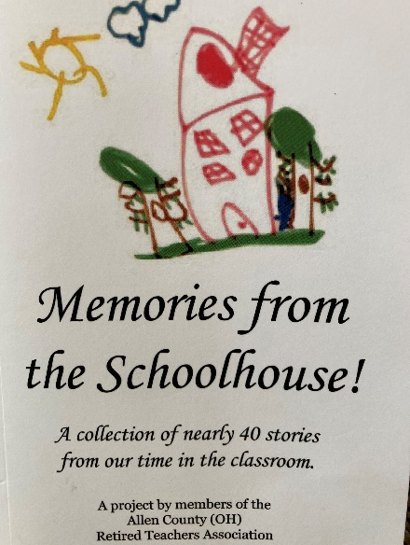
After months of gathering stories, we have a book! Thanks to David Reedy, ACRTA member, for making this possible!
Copies will be available at our October Meeting for $10.
You can also get a copy at Brunner’s News Agency/ Hallmark Stores, the Allen County Museum, Educational Provider’s and Art Space for $11 or call Barb at 419-303-5667 for a copy.
The book is also available on Amazon. Just search - Memories from the Schoolhouse and it will come up to purchase through Amazon or Kindle.
You will find stories that make you smile, maybe shed a tear, or find very heartwarming! A great idea for a birthday or Christmas or “just because” gift and it will help support our grant funds for Allen County teachers!
There is a way to contribute to ACRTA when you shop on Amazon. Please consider the below information.

Purchaser needs to do nothing other than use https://smile.amazon.com to shop and select ACRTA under their charity (shown with Rainbow Arrow!).

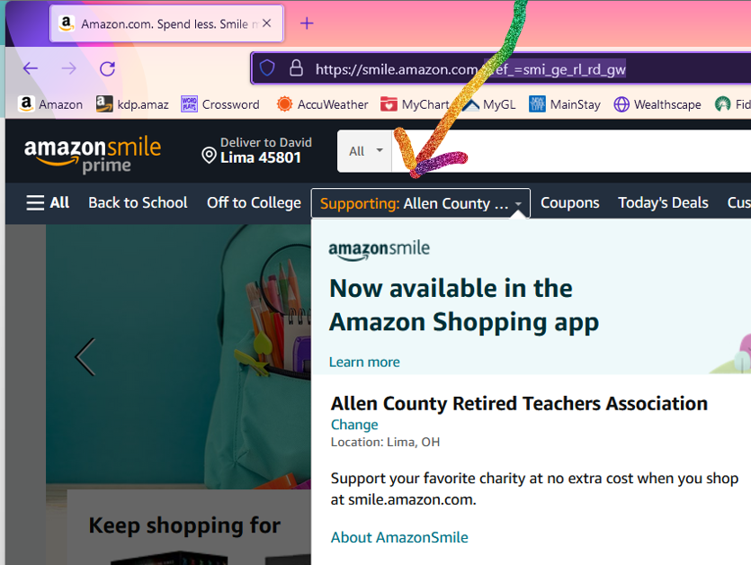
What is AmazonSmile?
AmazonSmile is a simple way for you to support your favorite charitable organization every time you shop, at no cost to you. AmazonSmile is available at smile.amazon.com on your web browser and can be accessed in the Amazon Shopping app for iOS and Android phones. When you shop with AmazonSmile, you’ll find the exact same low prices, vast selection and convenient shopping experience as Amazon.com, with the added benefit that AmazonSmile will donate 0.5% of your eligible purchases to the charitable organization of your choice. You can choose from over one million organizations to support.

~ ~ Message from the President ~ ~

Our organization has some exciting things happening. We have our first book published. Yes, I said first. Hopefully after you have read this book, you will see how easy it is to share a story. We already have one to start our next book and we can use yours too. I am excited that we have another funding source for our teacher grants through this venture.

I can’t thank the members enough for joining ACRTA with $2 of the dues automatically going into our grant funding, the ones that purchase raffle tickets and give loose change at our meetings and those that contribute more than the $2 when they join. We only can distribute the grants each year with the funds that are collected. The grant applications are out to the schools and will be read and given in early November.

It will be time to renew your ACRTA membership soon. Please also consider joining ORTA to support their efforts for more transparency from STRS and to reinstate the COLA. Attached on the last page of this newsletter is a 2023 membership form if you wish to check that off your “to do list” .

Our October meeting will busy. We will be electing a new president and secretary as those positions are term limited. There will also be copies of the revised bylaws that will be presented to the membership and then voted on for acceptance at the December meeting. Our book will be available for purchase and we will be forming a book committee. We also have a wonderful speaker for our program and the meal sounds delicious!

Please try to join us and enjoy the time together with fellow educators that are now also retired.

We have some members that are experiencing serious health issues. I ask that you remember them in thought and prayer.

Thank you to all that have joined our organization to keep it strong.
Barb 419-303-5667 bhochstetler001@woh.rr.com

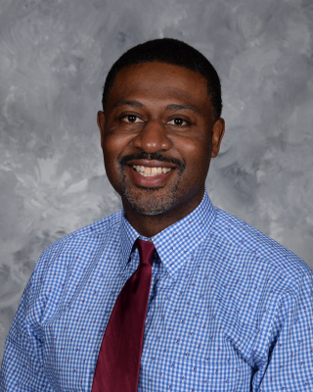
Ohio Teacher of the Year
Kurt Russell began teaching 25 years ago with the belief that education can transform students’ lives. Since then, this veteran teacher at Oberlin High School has taught multiple courses including African American history, U.S. History, international baccalaureate history of the Americas, and a course on race, gender and oppression.
Russell received teacher of the year awards from the Oberlin Heritage Center in 2009 and the Oberlin Chapter of the National Association for the Advancement of Colored People in 2019. In addition to teaching classes, Russell also serves as a lead teacher at Oberlin High School and as advisor for the Black Student Union, student council and junior class.
Since 1996, Russell has coached basketball for Oberlin City Schools. As the head coach of the boys varsity basketball team, he has received numerous awards, including the Lorain County Basketball Association’s Coach of the Year and the Northeast Ohio Coach of the Year.
Russell, who has always enjoyed learning about history, decided to become a teacher when he was in middle school.
He was inspired by his math teacher, who was the first Black male teacher he had in school. Russell went on to receive his Bachelor of Arts degree with a major in history and minor in Black studies from the College of Wooster. He obtained a Master of Education degree in curriculum and instruction from Ashland University, and he continues to take courses in child development at Oakland City University.
Source: ODE Website
2022 ACRTA Dates
General Membership Meetings - Lunch at 11:30 a.m. followed by program/meeting. *October 6th *December 1st
Board Meetings - 1:00 p.m. *November 3rd
~~~~~ Quote to ponder ~~~~~
"Autumn shows us how beautiful it is to let things go.” – Unknown

October
Doug Kent – 2nd Bonnie Snyder – 2nd
Kathy Kennedy – 3rd Don Smith – 6th
Deb Bohn – 7th John Bos– 10th
William Snow – 10th Shirley Wolf – 10th
Peggy Miller – 12th Linda Pugh – 12th
Kathy Gatchell – 14th Brenda Frazier– 15th
Teresa Savidge – 15th Devonne Dickrede – 16th
Marian Berry – 17th Maxine Smith – 21st
Barbara Gordon – 23rd Shannon Quinn – 26th
Norma Penn – 27th William Peebles – 28th
Sue Cramer – 30th
November
James Buffenbarger – 1st Brian Rockhold– 2nd
Linda Fangler – 3rd Dixie Coffman– 4th
Nancy Riegle – 4th David Adams – 5th
Debra Mullins – 6th Norma Johnson - 10th
Patty Lewis- 15th Joyce Busch – 22nd
Karl Blass – 23rd Marilyn Martz – 25th
Ruth Mowery– 26th John Byrne – 29th
Deb Nelson – 29th
**If we have missed you or have incorrect information, please contact us so that we can update our records.

The following are the proposed draft minutes for the August General Meeting
August 4, 2022
11:30 a.m.
Allen County Museum

Secretary’s Report: Norma Pen: Filed as printed.

Treasurer’s Report: Sue Cramer: We have a balance of $10,357.83. One grant was returned because of problems with ordering the supplies. $1,612 in the teacher grant funds. Filed for audit.

Membership: Norma Penn: We have 214 members for 2022.

ORTA: Continues to work toward restoring our COLA through legal means.

Legislative: When looking at our elections in November please check the veracity of the ads. Investigate the candidates. Keep in mind that abortion is a health issue.

Nominations: We need a new president and secretary due to term limits. Please consider running. We will be voting in October.

Old Business: Stories are still needed for our book initiative to raise funds for the grant program. Put in a biography of yourself. Saturday is the last day to turn them in to Dave Reedy.

New Business-STRS will be voting on bonuses at their next meeting, Thursday, August 18th.
AAUW book sale is September 6-10. Books are still being accepted.
ORTA’s 75th anniversary celebration is October 12th in Dublin

Raffle winner of the Ohio products baskets were Helen Thomas and Norma Penn.The winner of a free meal was Helen Thomas. We raised $116 for the teacher grants.

Next Program is Randy Overbeck.

Next meeting Thursday, August 4, 2022, 11:30 at Elida Emmanuel UMC.

Meeting adjourned at 12:56.

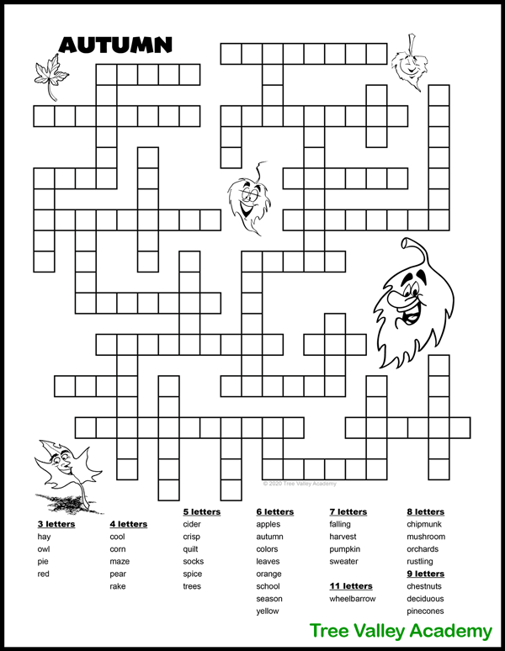
.

2023 ALLEN COUNTY
RETIRED TEACHERS ASSOCIATION

Jan. 1, 2023 to Dec. 31, 2023

Dues: ACRTA $12 ORTA $30

ACRTA __________ ORTA __________ GRANT ________
$12.00 $30.00 DONATION (optional)

Over 90 Dues are Free

Date paid ______ Cash ______ Check # ______
This information is for our directory and contact list.
Name:____________________________________
Address:_________________________________
City:__________________ State:_____________
Zip Code:_____________ Phone:_______________
EMAIL:____________________________________
Birthday: (mo.)____________(day)_________(year if you wish) _____
School Retired From:___________________
Please complete this form and return with cash/check written to ACRTA.

Send to: Norma Penn
809 Brendonwood Dr., Lima, Ohio 45801
419.303.8431 nleigh27catz@aol.com

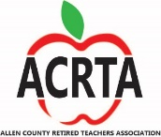 Welcome to the ACRTA!

